iPPAP – Supplier Manual
This document will take an Allison Transmission supplier through the steps of submitting a PPAP date, uploading documents and finally submitting a PPAP using the iPPAP system.
  - 5/21/2013
Table of Contents
- Version History 2
- Supplier Manual Functionality Description 3
- Functionality Execution 4
3.1 Supplier Schedules PPAP Date 4
3.2 Supplier Completes and Submits PPAP 12
- Appendix 31
4.1 Dashboard Columns 31
4.2 PPAP Statuses 31
4.3 PPAP Submit Date Status on Dashboard 31

- Version History
Revision Description | Page(s) | Date | Author
Original | 31 | 5/21/13 | Jack McCormack
2nd Revision | 31 | 6/3/13 | Jack McCormack

- iPPAP Process Steps

2.1 iPPAP Process Steps
Step | Responsible Party
- Create PPAP | Allison SQE
- Unschedule PPAP | Allison SQE
- Submit PPAP Date | Supplier
- Approve/Reject PPAP Date | Allison SQE
- Attach Documents/Submit PPAP | Supplier
- Approve/Reject Documents | Allison SQE

- Functionality Execution
  - Supplier Scheduling PPAP Date
- Supplier goes to: https://my.allisontransmission.com
  - NOTE: Internet Explorer 8 is the only web browser that is supported by iPPAP
- Supplier logs in

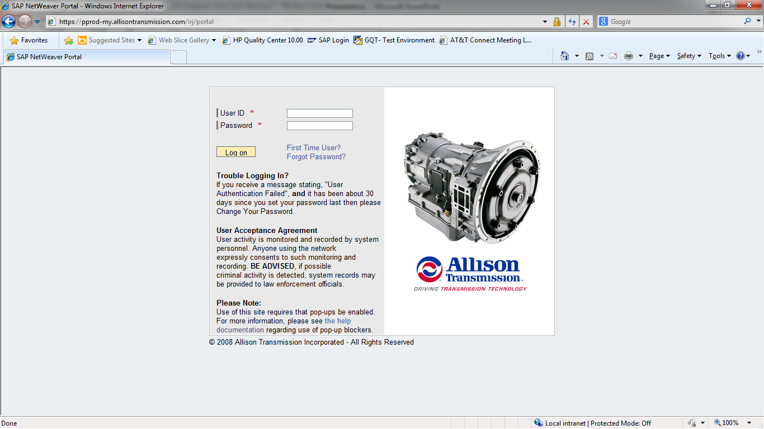

- Supplier Dashboard is shown:
  - NOTE: Once a PPAP shows up in supplier’s Dashboard and email, the PPAP date must be submitted within 30 days
  - See Appendix for explanation of columns

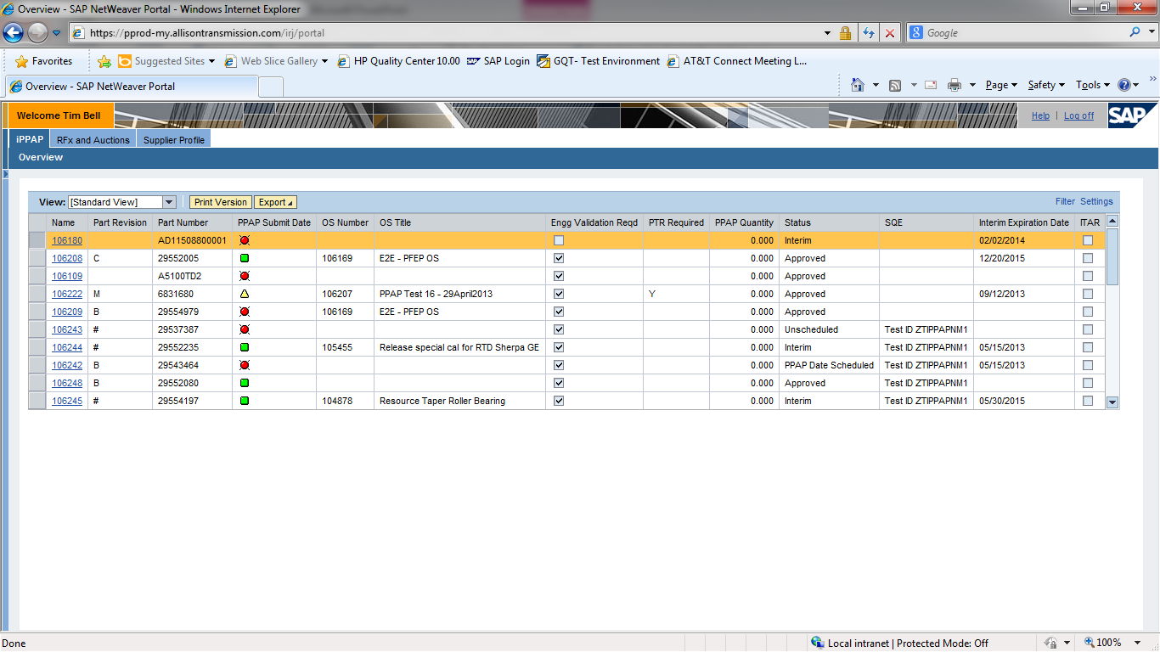
- Click on relevant PPAP Number
- Clicking PPAP number opens c-folder view

- Supplier selects Folder
  - NOTE – PPAP Requirements are listed under Folder dropdown menu
- Supplier selects Date Overview
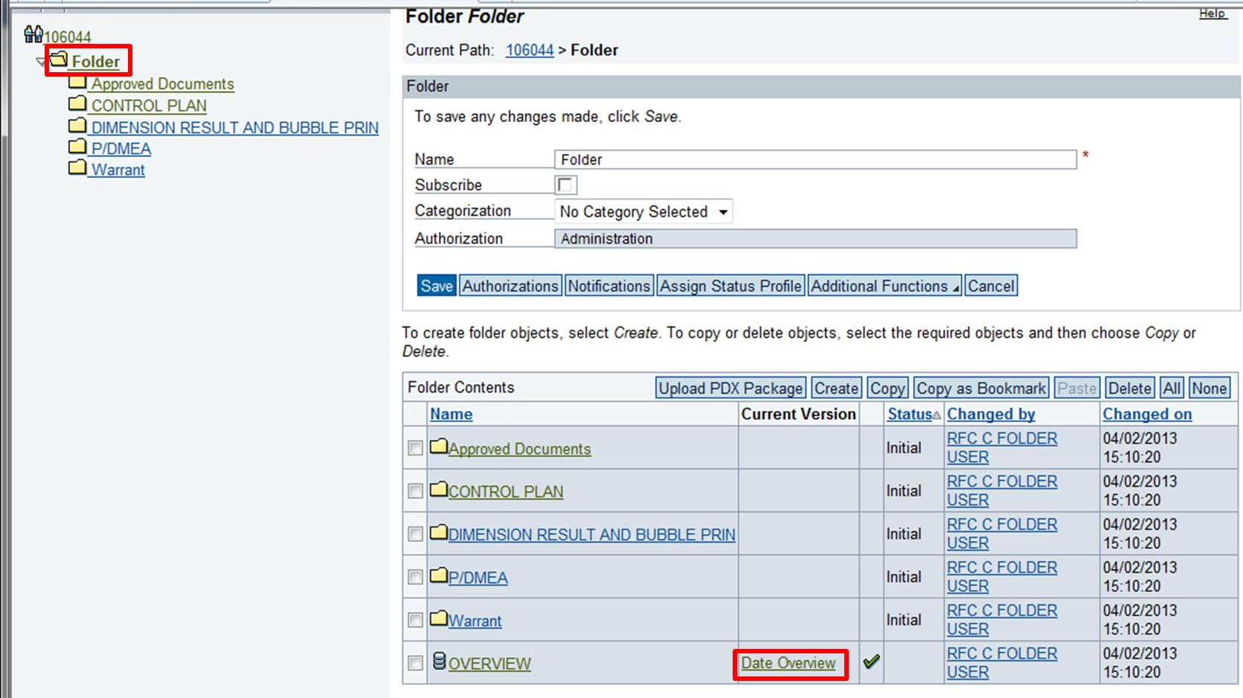

- Enter a PPAP Submit Date
  - NOTE – this is the date the supplier commits to completing PPAP
- Click Save

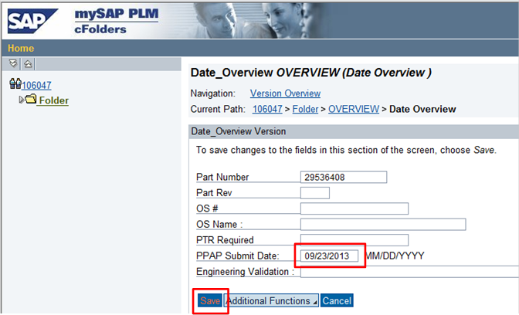

- Click the PPAP Number
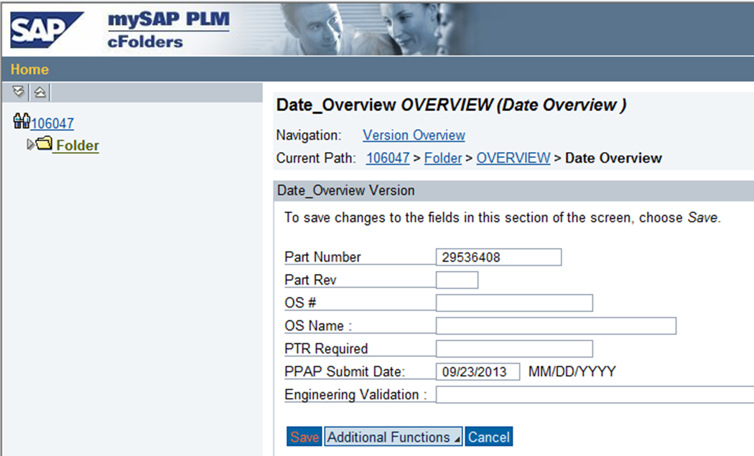

- Status automatically changes to “PPAP Date Submitted”
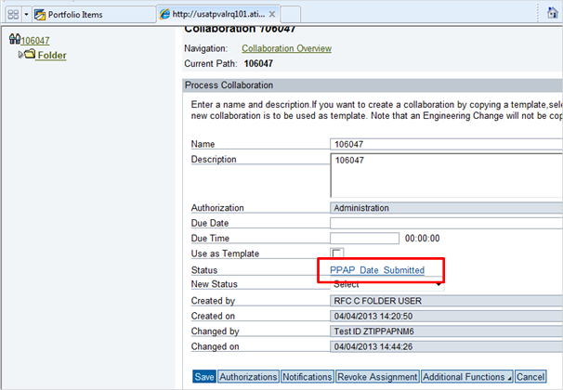

- STOP!!! Allison Supplier Quality Engineer will review the submitted PPAP Date and change status to “PPAP Date Scheduled” if approved. Once the PPAP Date is approved, supplier can complete PPAP requirements.

  - Supplier Completes and Submits PPAP
- Supplier goes to: https://my.allisontransmission.com
- Supplier logs in

- Supplier Dashboard is shown:

- Click on relevant PPAP number

- New window opens
- Select dropdown arrow to view folders
- Select a folder
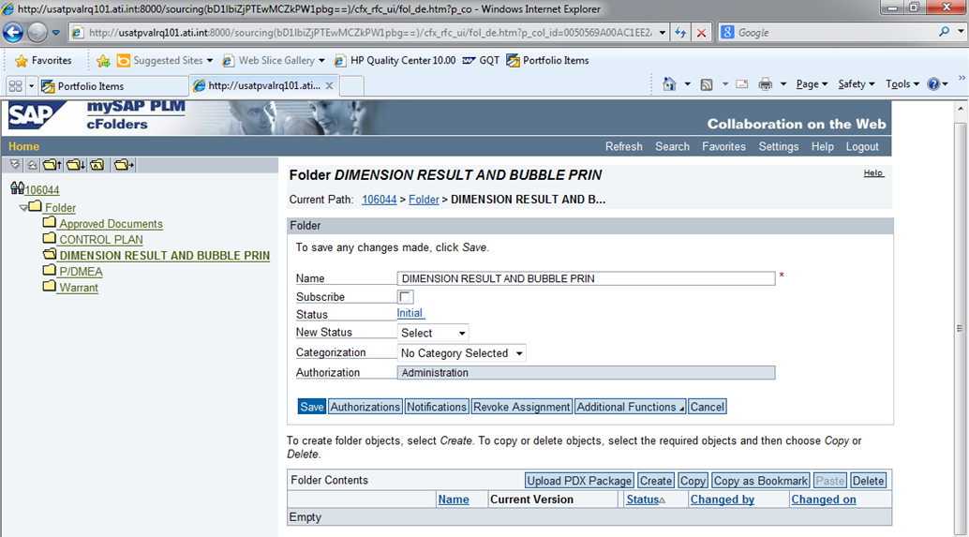

- Click “Create” to attach a document

- Click “Document”
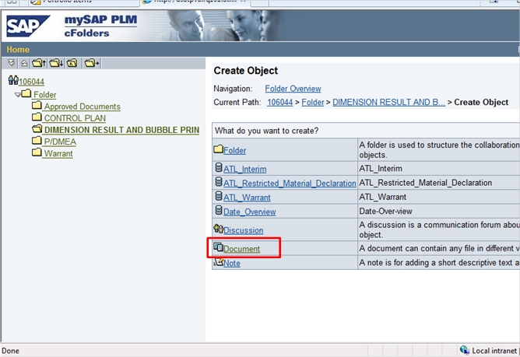

- Make sure “Upload Local File” is selected
- Click “Continue”
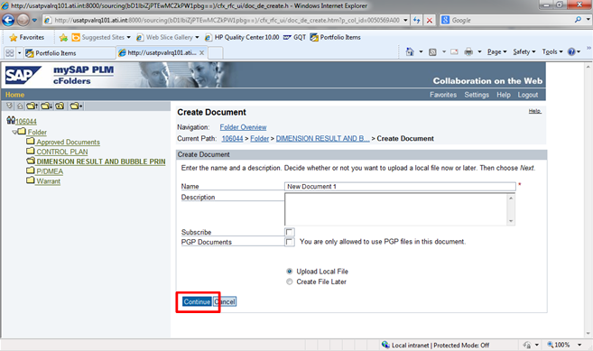

- Click “Browse”
- Select file
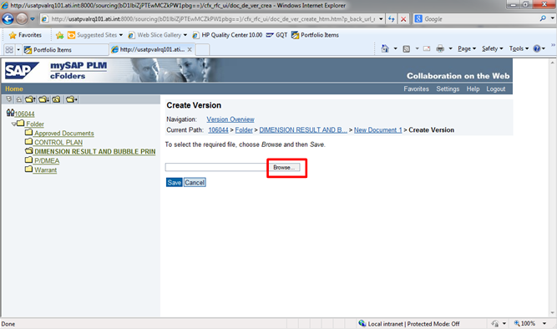

- Click “Save”
    - NOTE: If multiple documents are required, repeat steps 7 – 14.
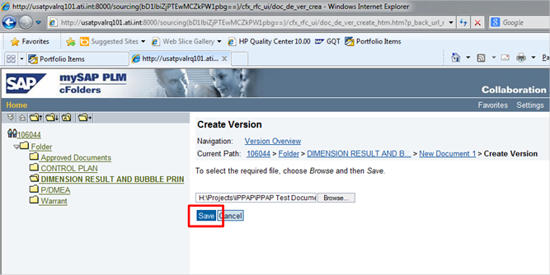

- Observe uploaded documents in folder
- Once all applicable documents have been uploaded into a folder, change status from “initial” to “submitted”
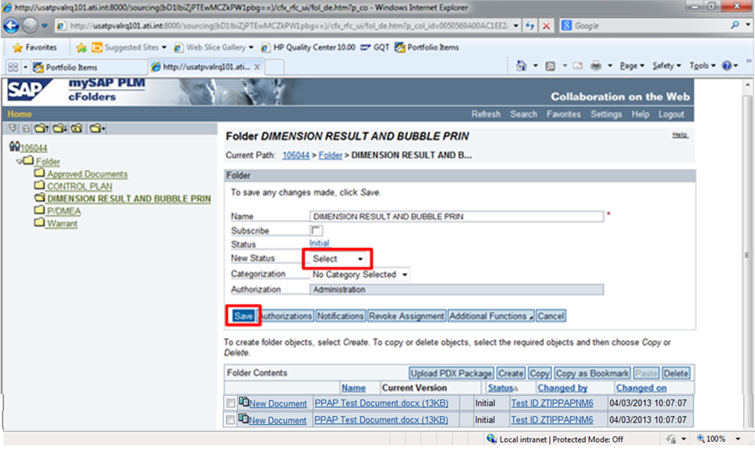

- New Status is “Submitted”
- NOTE – Once status is changed to submitted, the folder is locked, preventing further attachments. Supplier must contact Allison SQE to reopen folder. SQE will change status to “Initial”
- Click Save

- Repeat steps 7 – 18 until each folder has the necessary documents
- NOTE: Warrant, Interim and Restricted folders do not require document upload. They require data input.

- Click on the Warrant document
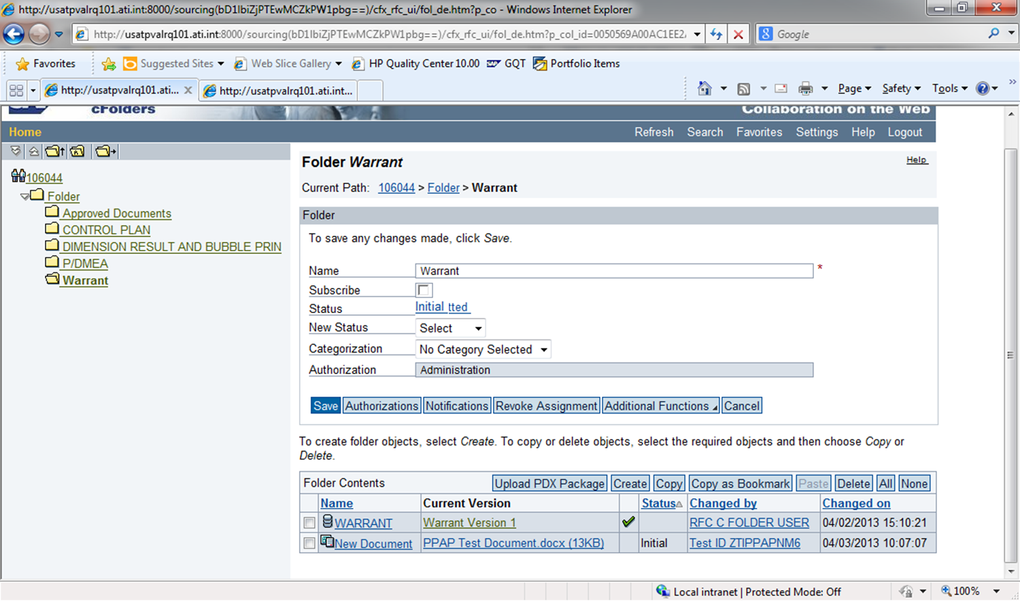

- Update Mandatory fields (*) and other applicable data
- Click “Save”
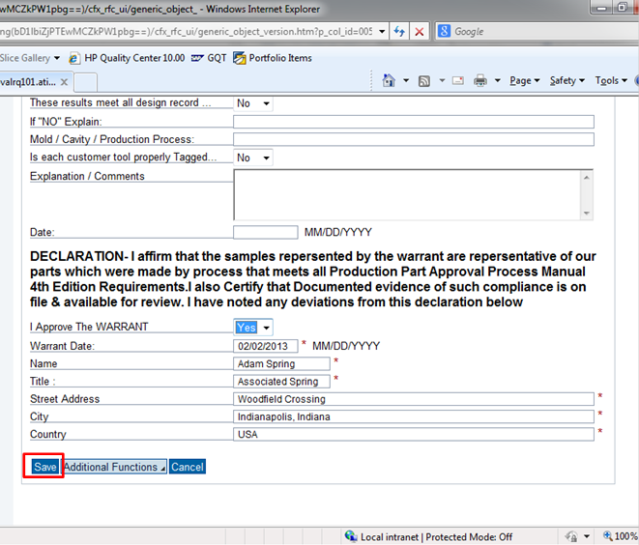

- Change Warrant status to “Submitted”
- Click “Save”
- Repeat steps 18 – 23 for Interim and Restricted folders, if applicable
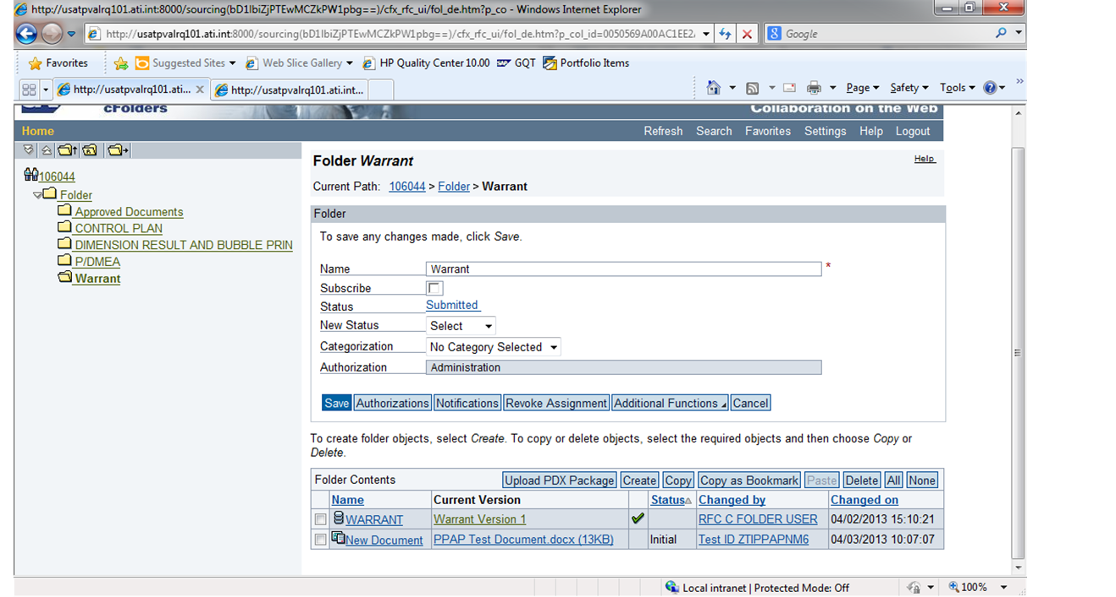

- Click on Folder to see all folder statuses

- Click PPAP Number

- Submit PPAP
- Click “Save”
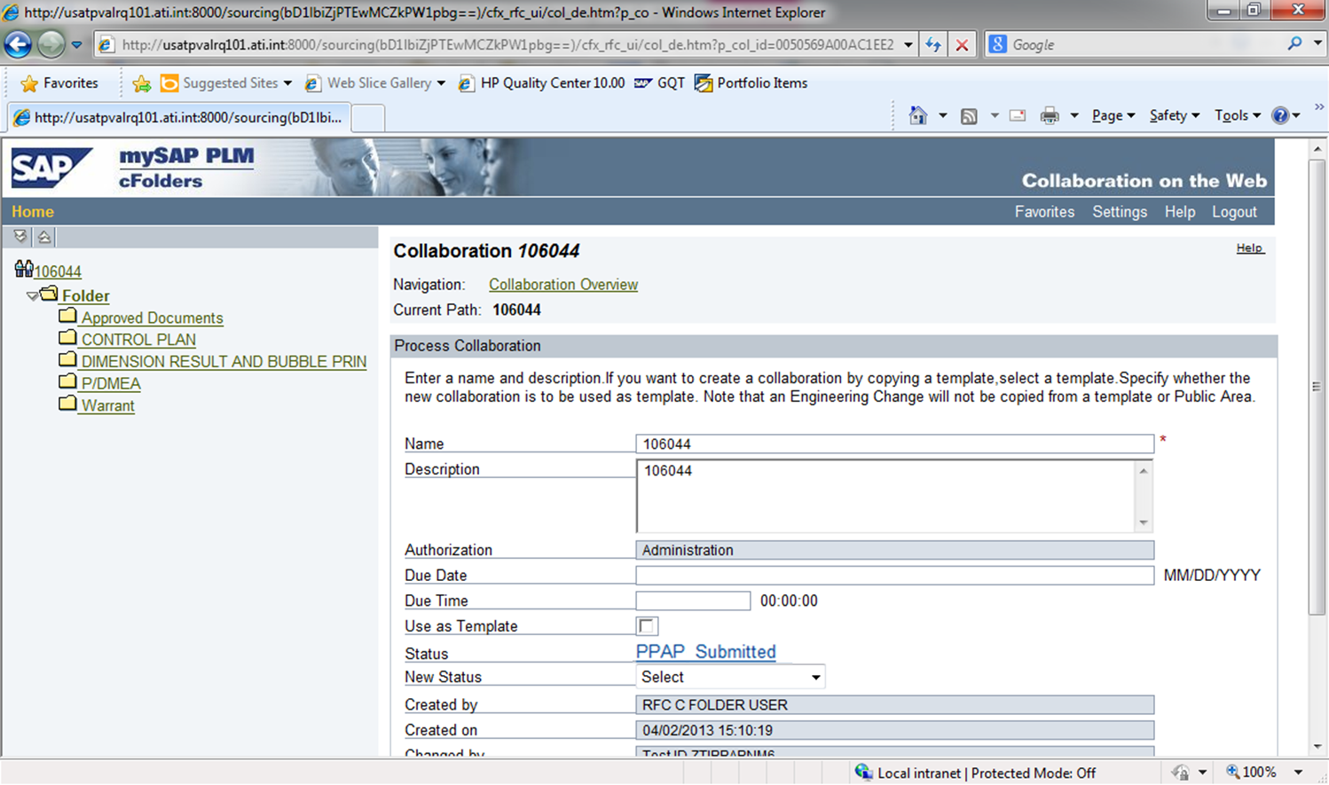

- STOP!!! Allison SQE will now review the submitted PPAP

- Appendix
4.1 Dashboard Columns
Label | Meaning
Name | PPAP Number
Part Revision | Latest Rev. Number
Part Number | Allison Part Number
PPAP Submit Date | Time left before Submit Date
OS Number | Number of OS that caused PPAP
OS Title | Title of OS that caused PPAP
Engg Validation Reqd | Engineering Validation Required – Yes or No
PTR Required | Yes or No
PPAP Quantity
Status | Current Status of PPAP
Interim Expiration Date | Date Interim Expires
ITAR | Yes or No

4.2 – PPAP Statuses
New PPAP
Unscheduled
PPAP Date Scheduled
PPAP Date Rejected
Initial
Submitted
PPAP Submitted
Approved
Rejected
Interim
Full PPAP

4.3 – PPAP Submit Date Status on Dashboard
Symbol | Meaning
 | Submit Date Passed
 | Less than 2 weeks before Submit Date
 | More than 2 weeks before Submit Date
Blank | Submit Date not scheduled

