February 23, 2023

Allison Transmission Supplier’s Authorized Person,

In order to be registered in Allison Transmission’s Identity and Access Management System (IdM), users must submit a combined on-boarding and (signed) citizenship verification letter. As a Defense Contractor, this information is required to facilitate proper access to certain Allison Transmission systems and/or facilities.

The following requirements relate to the on-boarding and citizenship verification letter.

- A sample template has been provided on the last page of this document for your use. It illustrates the required content and format for submittal. The tables should be copied and pasted onto your company's letterhead. Please ensure that the remaining information from the template is also included on your company’s letterhead.
- The citizenship verification letter must be on your company letterhead.
- The person verifying citizenship must be different from the person verified.
- The signature of the person verifying citizenship must be an actual signature, not digital.
- Do not send a zip file. PDF files are preferred.
- Do not send copies of birth certificates or passports. These formal identification documents must remain within the requestor’s company. Please only send the signed on-boarding and citizenship verification letter.
- Please send the completed letter as an attachment via e-mail to POReports@allisontransmission.com. Format the email subject line and attachment as follows: Vendor Code_Supplier Name_User Last Name_User First Name.

Please ensure that this letter and instructions are forwarded to and completed by the authorized party to conduct citizenship verification.

Regards,

Allison Transmission, Inc.

INSTRUCTIONS FOR VERIFYING CITIZENSHIP

Employers must verify each employee's citizenship via review of the following:
- Active (unexpired) Passport or
- Certified Copy of Birth Certificate and
- Copy of Marriage Certificate if name on item #1 or #2 does not match employee's current last name.
- In the case where a foreign-born person has been granted permanent residency within the United States, an original copy of the permanent residency documentation, such as an unexpired Green Card, must also be reviewed.

Social Security cards or driver's licenses do not establish citizenship and cannot be used for citizenship verification purposes.

__________________________________________________________________________________

Definitions:

Person as defined by 22 CFR §120.14: Person means a natural person as well as a corporation, business association, partnership, society, trust, or any other entity, organization or group, including governmental entities.

U.S. Person as defined by 22 CFR §120.15: U.S. person means a person (as defined in § 120.14 of this part) who is a lawful permanent resident as defined by 8 U.S.C. 1101(a)(20) or who is a protected individual as defined by 8 U.S.C. 1324b(a)(3). It also means any corporation, business association, partnership, society, trust, or any other entity, organization or group that is incorporated to do business in the United States. It also includes any governmental (federal, state, or local) entity. It does not include any foreign person as defined in
§ 120.16 of this part.

Foreign Person as defined by 22 CFR §120.16: Foreign person means any natural person who is not a lawful permanent resident as defined by 8 U.S.C. 1101(a)(20) or who is not a protected individual as defined by
8 U.S.C. 1324b(a)(3). It also means any foreign corporation, business association, partnership, trust, society or any other entity or group that is not incorporated or organized to do business in the United States, as well as international organizations, foreign governments and any agency or subdivision of foreign governments (e.g., diplomatic missions).
__________________________________________________________________________________

A sample citizenship verification template follows. It is recommended one should copy the body of the sample template and paste it onto company letterhead for ease of completion.

LINEBACKER LIMITED
93 Freeney Fairway
Indianapolis, IN 46222

EXAMPLE
Date

Allison Transmission, Inc.
One Allison Way
Mail Stop J13
Use your company letterhead
Utilice el membrete de su empresa
Indianapolis, IN 46222

Reference: Citizenship Verification

This letter provides citizenship verification information for the employee referenced below. As the employer of this employee, I confirm that citizenship information has been verified in accordance with instructions provided by Allison Transmission, Incorporated.
Employee Legal First Name
Employee Legal Last Name
Supplier Name from Federal Form W-9
Allison Supplier Code
Employee Email Address
Employee Phone Number
Employee Birth Month
Employee Birth Day

The above referenced employee is:
A U.S. Person
A Foreign Person with the following countries of citizenship:
Birth Country
Current Citizenship
Additional Citizenship
Additional Citizenship

Sincerely,
Name and title of authorized person certifying citizenship - cannot be same as employee above
Signature must be handwritten and not computer generated
Nombre y título de la persona autorizada que certifica la ciudadanía - no puede ser igual que el empleado anterior
Firma debe ser a mano y no generado por computadora
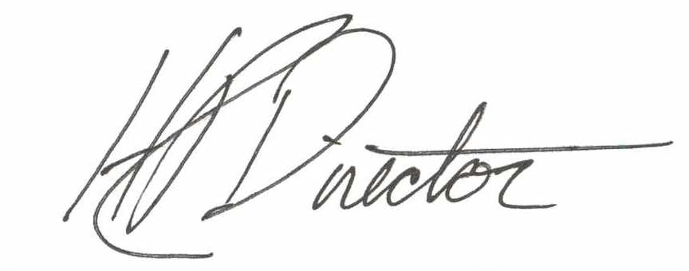
H. R. Director {Name}
Personnel Supervisor {Title}

