***Example Summary***

|  |  |  |  |  |  |  |  |  |  |  |
| --- | --- | --- | --- | --- | --- | --- | --- | --- | --- | --- |
| Allison PO # | Item # | **Qty** | **Allison Product Part Number** | **VTA# (Vendor Tooling Asset)** | **Supplier Tool #** | **Tool / Gage Description** | **Size**  **W x L x H** | Weight | **Tool Location** | **Storage Location** |
| 111**5 | 1 | 2 | 2950xxx7 | PR1234-1 | 20460-B | (4) Cavity Mold | 18 x 24 x 18 (IN) | 1,200 Lbs | ASD Co., Peru, IN | Mold Rack A-3 |
| 100**7 | 1 | 1 | 2953xxx7 | PR1234-2 | 58137 | Go / No-Go Spline Gage | 9” Dia x 2.5” | 10 Lbs | XYZ Co., Troy, MI | Insp. Cab # 6-2 |
| 100**7 | 2 | 1 | 2953xxx7 | PR1234-3 | 60147 | Go Plug Gage | 3.0000” x 7” | 4 Lbs | XYZ Co., Troy, MI | Insp. Cab # 3-4 |
| 100**7 | 3 | 1 | 2953xxx7 | PR1234-4 | 60148 | No-Go Plug Gage | 2.992” x 7” | 4 Lbs | XYZ Co., Troy, MI | Insp. Cab # 3-4 |
| 100**7 | 4 | 1 | 2953xxx7 | PR1234-5 | 70199 | Go Spline Gage | 6” Dia x 1” | 3 Lbs | XYZ Co., Troy, MI | Insp. Cab # 5-6 |
| 100**7 | 5 | 1 | 2953xxx7 | PR1234-6 | 70200 | No-Go Spline Gage | 6” Dia x 1” | 3 Lbs | XYZ Co., Troy, MI | Insp. Cab # 5-6 |

***Example of Tool Pictures Required***

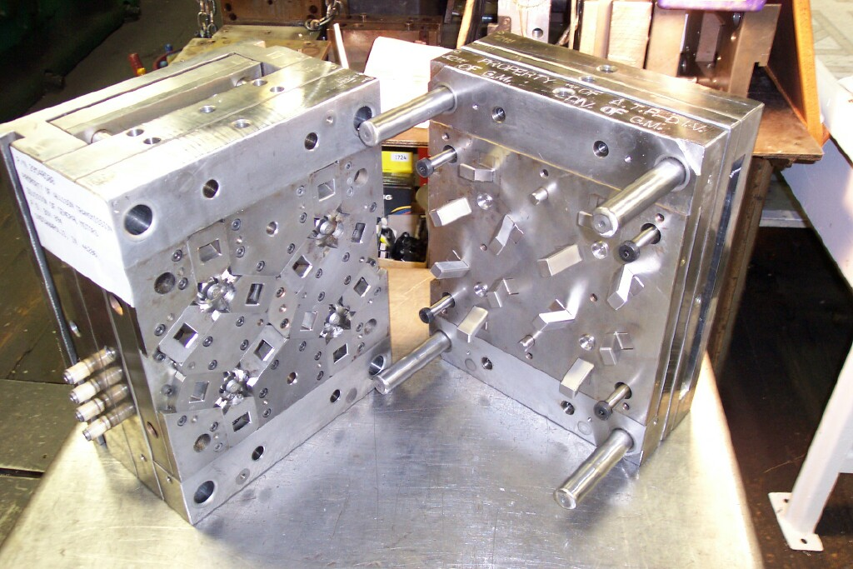

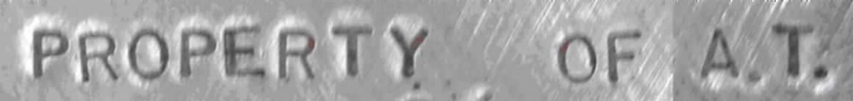

**Mold # 20460-B, (4) Cavity Mold, Allison P/N 2950xxx7, OP. 10**

**Located at Tier II Supplier, ASD Co., Peru, IN**

***Example of Gage Pictures Required***

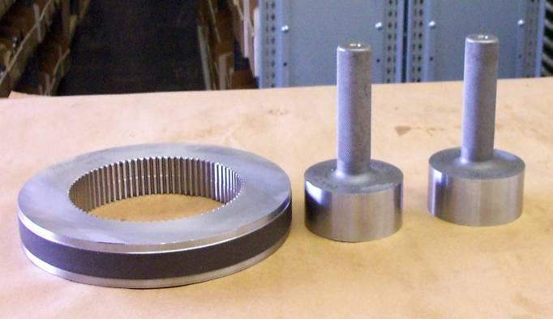

#2

#1

#3

**Various Gages (see Summary Sheet), Allison P/N 2953xxx7, OP. 30**



#4

#5

Go / No-Go Spline Gages, Allison P/N 2953xxx7, OP. 50

***Note: Tools & Gages Must be Permanently Marked as ‘Property of ATI’***